**Education Expenditure and Economic Growth**

**The Role of Education Quality for Developing Countries in Europe**

**Abstract**

Knowledge-intensive modern economies made human capital more essential than ever for long-term economic growth. Thus, education as the main channel of human capital formation became an important subject in development economics. This paper examines educational quality’s effect on the relationship between education expenditure and economic performance in Europe’s developing countries. Threshold Regression is used for analyzing the effectiveness of education expenditure for both sides of the education quality threshold and Data Envelopment Analysis is applied to estimate relative expenditure efficiencies of the selected countries. Average PISA results are used as a quality measure in both models. The findings indicate that education expenditure expansion can promote economic growth only if educational quality is above a certain threshold. Reaching this threshold level is strongly related to the efficiency of education expenditure. In the long run, developing countries in Europe can achieve sustainable economic growth with an efficiency-based strategy that is focused on higher quality of education.

metin içeren bir resim

Açıklama otomatik olarak oluşturulduApplying Economics

Mert Ekici 2741471

m.ekici@student.vu.nl

**Table of Contents**

1. **Introduction**……………………………………………..……….………………………………...3
   1. Human Capital, Education and Growth ………………………….…………………………3
   2. Developing Countries in Europe…..…………………………………….………………….3
   3. Expenditure and Quality………………………………..………………………..…………4
   4. Research Focus…………………………………………………………………..…………4
2. **Literature Review**………………………………………………………...………………………..4
3. **Theoretical Framework**…..…………………………………………………..………….………..6
   1. Human Capital and Education………..…………………………………………………….6
   2. Neoclassical Growth Model…...…..……………………………………………………….7
   3. Quantity and Quality of Education..………..…………..…………………………………..8
   4. Market Benefits of Education ….…………………………………………………………..8
4. **Empirical Strategy**..………………………………………………………………...…………...…9
   1. Data……………………………………………………………...…………………………9
   2. Education Expenditure and Growth Equation…...………………………………………….9
   3. Quality and Educational Achievement………...……………………………….................10
   4. School Attainment and the Quality of Education..……………………………………..….10
   5. Cross-Country Growth Analysis and the Threshold Regression………………..................11
   6. Data Envelopment Analysis and Efficiency Score..…………………………………….....11
   7. Data Visualization and Comparison………………………………………………………14
5. **Statistical Results**………………………………………………………………………................14
   1. Results of Education Expenditure and Quality..…………………………………………..14
   2. Descriptive Statistics……………….……………………………………………………..15
   3. Empirical Results…………………………………………………………………...……..17
6. **Conclusion**…………………………………………………………………………………...…....22
7. **Appendix**………………………………………………………………….....................................24
8. **References**………………………………………………………………………….......................30

**I. Introduction**

*Human Capital, Education and Growth*

The role of human capital in economic growth is one of the most fundamental principles of development economics and education can be considered as a significant way of human capital investment (Benos & Zotou, 2014). Education, as the main channel of human capital accumulation, improves the quantity and quality of labor for the development process. The other functionality of education is that it encourages countries to follow or produce modern technologies to be used in the production process. Due to these advantages of education, we became more convinced that the educational sphere should be prioritized. Paying enough attention to the development of education and raising qualified workers for the modern requirements of the world are important concerns for many countries in the 21st century. Thus, it can be inferred that an effective way of sustaining growth is through educational development.

*Developing Countries in Europe*

Increased labor productivity with higher levels of education impacts countries’ competitiveness. Furthermore, education level differences between countries can be counted as one of the main reasons for the economic performance gap between developed and developing countries (Mercan & Sezer, 2014). Education’s vital role in the economic development process has been addressed by a large number of studies. This paper’s scope will be limited to developing countries in Europe since the effect of education in closing the gap between developed countries is a crucial area of interest for many developing countries. Accordingly, Bose et al. (2003) concluded that education is the key factor to the growth of developing countries based on the empirical findings using panel data of thirty developing countries. Jointly with economic growth, higher employment and quality education, better health services are included in development goals by the majority of countries. Achievement of long-term sustainable development goals is the ultimate aim for developing countries. Countries use different instruments to achieve development goals and maintain growth. Based on the case study of Central and Eastern European countries, it is pointed that the most effective state instrument for SDGs is state-financing of education (Vorontsova et al., 2020). For the 14 countries of Central and Eastern Europe between the years 2006-2016, Vorontsova et al. (2020) confirmed that the goal of promoting sustained economic growth can be achieved by funding the education sector.

Efficiency of governments’ public expenditure on education is another topic of discussion. Education expenditures are able to promote growth only if educational quality is above a certain threshold (Trabelsi, 2017). The term “*education quality”* used here refers to the results of some quality proxies that evaluate educational systems such as PISA, PIRLS, PASEC and TIMSS (educational achievement tests from different organizations to determine education qualities). Since developing countries in Europe have higher scores in these quality measures and they are more likely to exceed the education quality threshold, this study is concentrated on Europe’s developing countries to examine the effect of educational characteristics on growth. In addition, developing countries in Europe have higher education spendings compared to other developing countries (based on data from World Bank, OECD and Eurostat) which makes the economic performance gap easier to be closed. Based on IMF’s World Economic Outlook (2021), developing and emerging economies of Europe were collected and the countries with the highest GDP per capita PPP (World Bank) were selected as follows: Bulgaria, Croatia, Hungary, Poland, Romania, Russian Federation, Turkey.

*Expenditure and Quality*

In this study, expenditure and quality characteristics of education, and their impact on economic growth will be investigated with the aim of revealing the causal relationship between these concepts for developing countries in Europe. As the first focus of this paper, education expenditure appears to be highly important for economic development which is the main motivation for the selection of this determinant. Around the world, many governments have taken notable actions for financing education with various justifications. However, a common motivation for this act is that education expenditure is the key factor to accelerated economic growth and its sustainability (Blankenau et al., 2007).

Besides education expenditures, developing countries have focused on school attainment and they have shown substantial progress where they were able to close most of the educational attainment gap with the developed countries (Hanushek, 2013). Nevertheless, school attainment expansion is not desirably effective on growth when educational quality remains at lower levels. Recent studies have concluded that cognitive skills supported by a higher quality of education (rather than only school attainment) are strongly related to economic growth (Hanushek & Woessmann, 2007). Accessibility of education, the number of educational institutions and provided resources through government expenditures are critical components of human capital investments. However, without improving education quality, developing countries are incapable of improving their long-term economic performances. For these reasons, educational quality is the second characteristic that will be inspected in the paper.

*Research Focus*

Developing countries and emerging markets have become more knowledge-intensive in recent years which increased the significance of human capital and education. This paper aims to reveal the link between education expenditures, human capital accumulation and sustainable growth for developing countries in Europe. As an alternative to previous studies, the impact of education quality on this link will be examined as well. The research question is developed as follows:

*What is the effect of education expenditure on economic growth in Europe's developing countries and how is this effect related to educational quality?*

**II. Literature Review**

The importance of technical knowledge and human capital in the economy has been studied for a long time. Specifically, education-related issues have been highlighted by several approaches and a wide range of studies have examined education’s impact on economic performance. Major samples of literature related to our study focus will be reviewed in this section. Previous studies focused on the relationship between education and economic growth can be categorized into four groups based on their content and relation to this research. Review of these studies are grouped based on their categories and they are given within the time frame.

First, the relationship between education expenditure and growth has been discussed in earlier studies to understand how governments can support human capital accumulation with increased education expenses. Bose et al. (2003), examined the growth effect of education expenditures for a panel of thirty countries. Their analysis strongly suggested that education is a key to economic prosperity. In parallel with the modern growth theory, the increase of government education expenditure’s share in GDP appears as a growth-enhancing change (Bose et al., 2003). Blankenau et al. (2007) tried to support the theory and education’s key role in growth with empirical analysis. Similarly, they found that a positive relationship between education expenditures and growth exists for developed countries. From an empirical point of view, these studies use different model specifications to test the relationship between human capital and economic growth. Depending on the study aim, different types of instruments can be useful and the selection of suitable models is critical for the research. Results can vary depending on the empirical approaches used in these researches. To obtain feasible results with better estimations, it is understood that the development of the empirical strategy is vital. Benos and Zotou (2014) applied meta-regression analysis to 56 studies to clarify these differences and the reasons behind them for detecting publication bias which can be explained as a bias depending on the direction or the nature of the results and methods used in the study (e.g. a paper is more likely to be published if the results are reasonable and statistically significant). They attributed these differences to education characteristics and empirical methods of each research. Final results showed that the inclusion of public expenditures, education enrollment, political measures and test scores in the model can lead to correction for publication bias if panel data or cross-section is used instead of log specification and time series (Benos & Zotou, 2014).

The second category of the literature on education and economic growth contains studies focused on the quality of education. World Bank has mostly focused on this characteristic of education in the last decade. Thanks to its large database, World Bank conducted several policy researches on the education quality including the majority of the countries within a large time period. Hanushek and Woessmann (2007) reviewed the role of education in economic development by particularly focusing on the quality of education. Governments around the world have focused on school attainment for many years. However, expansion of school attainment was not a guarantee for the improvement of economic conditions. Rather than mere school attainment, cognitive skills of the population and improved school quality were associated with economic growth (Hanushek & Woessmann, 2007). Furthermore, Altinok et al. (2018) used a database that includes 163 countries and regions for the years 1965-2015. This study is thereby the largest and most recent dataset that covers more than 90 percent of the population and it used credible educational achievement measures to determine the quality of education. The paper found a significant positive relationship between economic growth and educational achievement with a stronger association, rather than years of schooling alone, according to cross-country regressions. Even though the association between educational quality and economic growth is observed by various studies, each country has different quality requirements with different potentials to utilize quality on their economic performance. Determinants can vary on how much they can benefit from their educational level. Yet, the direct mechanism of educational quality in this process is still missing and can be estimated by comparing these countries with the control of the related indicators.

After the studies on educational quality emerged, it was understood that developing countries have the most to gain from high-quality education’s potential benefits. The third category of the literature is mostly focused on similar topics but this time developing countries are the area of interest, which is different from previous work. In his research, Hanushek (2013) indicated that developing countries find it difficult to boost their economic performance without improving school quality. Besides education quality, formal education system can influence the effectiveness of education expenditures too. Mehrara and Musai (2013) pointed out that if the education system is not market-oriented, huge educational investments in developing countries might fail to generate growth. Their suggestion was to promote practice-oriented training for the needs of the labor market. As for educational expenditures, literature has been directed towards developing countries again. Mercan and Sezer (2014) obtained positive results for Turkey between 1970-2012 in terms of the effect of education expenses on economic growth. An additional remark of their study was that more resource allocation, especially in higher education, can have a stronger contribution to the economic growth process. Moreover, Appiah (2017) asked the same questions for Sub-Saharan African developing countries. By using panel data of 139 countries for the period 1975-2015, Appiah’s comparison results showed that the effect was still positive and significant for SSA countries.

Finally, the latest literature on education and growth (the fourth category) targets the efficiency of education expenditure and the threshold effect of education quality. For the limiting effect of education quality, the results of Trabelsi (2017) showed the existence of education quality’s threshold effect. Specifically, expenditure caused a positive effect on growth if education quality is higher otherwise it was negative or not effective. After the findings of this research, the efficiency of education expenditure became an important question for the literature. Only efficient government expenditures on education can generate sufficient returns and contribute to economic growth. Ahec Sonje et al. (2018) examined the efficiency of education expenditures in the new member states in the EU with a particular focus on Croatia with several methods including the education quality threshold. The results supported Croatia and Bulgaria’s high inefficiency of education expenditures. By looking at the evolution of the literature on education and growth, we can see that two important concepts appear as the ultimate answers for the question of education-driven sustainable development: threshold quality and expenditure efficiency. On top of that, literature does not have an approach that includes both of these concepts which is the main purpose of this study.

**III. Theoretical Framework**

*Human Capital and Education*

Human capital is defined as the set of knowledge, skills and abilities embodied in individuals. People invest in human assets and human capital can be acquired through training or education (Schaffner, 2014). According to the theoretical growth literature, there are three major mechanisms by which education affects economic growth through human capital (Brewer & McEwan, 2010). First, human capital in the labor force can be increased by education which enhances labor productivity. Thus, growth transitions to a higher equilibrium level. Second, education can promote innovative capacity by increasing the production of new technologies and knowledge within the country. Third, the transition and adaptation to new technologies produced by others can also be facilitated by education using the ability to process and understand new information. Consequently, countries can successfully implement and utilize the new technologies for the production process.

*Neoclassical Growth Model*

There are several approaches that explain the relationship between education expenditures and growth in literature. Keynesian modeling framework hypothesizes that government spending expansion stimulates economic growth. Therefore, education spending can be counted as an important determinant of developing countries’ economic growth (Appiah, 2017). In the Neo-classical approach (The Augmented Solow Model or Solow-Swan Model), the production function used to measure growth and equilibrium is stated as follows;

* Y denotes economy’s gross domestic product,
* K refers to share of capital,
* L represents the unskilled labor,
* A describes level of technology.

After the 1960s, the notion of human capital became popular with several pieces of research on the role of human capital accumulation and productivity (Schaffner, 2014). Researchers revised Solow’s model and considered augmenting it with human capital as an additional factor of production. Mankiw et al. (1992) replaced Solow’s aggregate production function as;

where H is human capital. The human capital factor is included in the model to highlight the effect of human capital on the income difference between countries (Mercan & Sezer, 2014). After that, investment in education became the main aim to promote development and growth (Schaffner, 2014). If we interpret the three mechanisms of education to boost economic growth through the Neoclassical Growth Model with Human Capital;

1. Education increases labor productivity which directly affects output through human capital.
2. Innovative capacity of the economy is increased by education. With the creation of new technologies and knowledge, A (technical knowledge), H (human capital), and indirectly K (capital) can be increased.
3. Transmission and adaptation of the new technologies to be used in the production process can also affect capital accumulation and technical knowledge through human capital factor.

Economic Growth

*Figure 1: Education-Growth Model*

*Quantity and Quality of Education*

Education affects growth through two main characteristics: quantity and quality. Accessibility in education, quantity of educational institutions, enrolment rates, average year of schooling, or more generally school attainment are different measures of educational quantity. Education quality on the other hand, is measured by the knowledge gained by students and the level of cognitive skills. Strong causal link between cognitive skills and economic growth made a number of quality-related arguments appear in the literature. Barro (2001) found that both quality and quantity of education matter for economic growth but the quality is much more important. One year of schooling does not cause the same improvement in knowledge regardless of educational quality, but different results can be observed depending on the efficiency and quality of the education system (Hanushek, 2013). Hence, Hanushek (2013) suggests that policies that targeted improvement in school quality have a direct effect on growth and income distribution.

*Market Benefits of Education*

There are two main returns of education investments, “market and non-market” (Appiah, 2017). Since the non-market benefits are outside of the scope of this research, only the theoretical content of market benefits will be mentioned in this part. Education’s market benefits consist of private and public benefits (Appiah, 2017). As pointed out in previous sections, private benefit is critical because it improves the productivity of individuals on the job which is advantageous for the labor market. Additionally, higher salaries and better employment prospects are included which clearly leads to greater opportunities to save and invest. All of these benefits help to afford better health services and accordingly improved life quality. Social or public market benefits can be described as benefits for society through increased employment rates and increased tax revenues to be spent on better public services (Appiah, 2017). According to Appiah, in terms of externalities of private benefits, beneficial effects of education for society and future generations are usually underestimated or confused with private benefits. Due to the prior generations’ education knowledge, benefits of today are achieved but often this is categorized as private benefit of someone’s investment decisions. Since these non-excludable and non-benefits are shared equally by society, they can be referred as “public goods” which are mostly positive externalities on growth (Mankiw, 2007).

* Based on the theoretical framework, this study will use several empirical methods and publicly available comprehensive data to examine the relationship between the concepts of education expenditure, educational quality and economic growth for the selected developing countries in Europe.

**IV. Empirical Strategy**

*Data*

This study covers selected developing countries in Europe: Bulgaria, Croatia, Hungary, Poland, Romania, Russian Federation, Turkey. Main datasets for the study are World Development Indicators database and Education Statistics – All Indicators database of World Bank which also include selected countries for the time period between 1970-2020. Additionally, Barro and Lee Dataset for educational attainment is used as complementary for missing variables in models. Panel and cross-country data are used in the methodology since they are specified as better fits for a less biased education-growth study, according to the meta-regression analysis (Benos & Zotou, 2014).

Other parts (comparison of selected countries) of the research are based on publicly available data obtained from the websites of international institutions such as OECD (PISA results), UNESCO database, World Bank, Eurostat. Obtained data is visualized in several graphs, charts and tables that contain selected countries’ education expenditure, quality and growth characteristics.

*Education Expenditure and Growth Equation*

As introduced in the theoretical framework, the neoclassical model was transformed due to the relationship between technology and labor.

🡪

In the model of Appiah (2017), K or the stock of capital is proxied with education expenditure (as capital investment on education). Per capita GDP is represented by Y which is a function of education expenditure (, labor force (, and (vector of control variables). Including control variables, the equation appears as follows:

where t indexes time and i indexes observational units. is the log of GDP per capita or log(Y), is education expenditure, represents labor force, is for the quadratic term of labor, and describe gross primary enrollment and gross secondary enrollment respectively and finally shows that export rates (Appiah, 2017). The dummy variable for the examination of Sub-Saharan African countries’ effect is excluded since it was not related to the study. Given equation is not directly used in this study but the findings of this empirical method and the mechanism that affects economic growth are critical for the study focus.

*Quality and Educational Achievement*

In the Global Data Set on Education Quality, Altinok et al. (2018), used measures of globally comparable education achievements with high credibility. In the research, multiple linking methods were used. The availability and coverage of ISATs (International Student Achievement Tests) are increasing but still, there are limitations of these testing methods. First, some of the tests are highly correlated which makes it difficult to use them in the same analysis without detailed examination. Second, these assessments usually include Organisation for Co-operation and Development (OECD) countries and since they started being used recently (SSA countries are excluded), their ability for the conduction of longitudinal panel analysis is limited (Altinok et al., 2018). Therefore, the study uses international and regional standardized achievement tests to identify and elaborate educational quality. Using mean and percentile linking and enhancing the robustness with a huge dataset, the empirical findings of this paper are highly contributive to the literature and our research area. Thus, empirical results of this policy research paper of World Bank will be interpreted and discussed in the following steps.

*School Attainment and the Quality of Education*

Son et al. (2013), based their model in order to examine the education quality role in the economic growth process. The model includes the education quality variable measured by skill test scores with a number of control variables including school attainment. The log-log model goes as follows:

* 🡪 logarithmic value of per capita GDP of the country i withing year t
* 🡪 physical capital
* 🡪 average year of education
* 🡪 quality of education
* 🡪 the degree of international openness
* 🡪 life expectancy rate
* 🡪 inflation rate

In addition to the expenditure-growth model, a model that includes school attainment and quality to follow their effect on economic growth is complementary to the research aim of this paper. Results from these two different models will be compared in terms of their effect on economic performance and links to each other. After the results from the studies that used these models are discussed, selected countries’ education-growth relations will be analyzed using the following methods. With the cross-country growth analysis and threshold regression, the educational quality threshold will be determined for selected countries and after, each country’s efficiency score will be calculated.

*Cross-Country Growth Analysis and Threshold Regression*

Most of the previous studies have analyzed the relationship between education expenditure and economic growth using the following linear cross-country growth analysis model (Trabelsi, 2017).

**Linear Cross-Country Growth Model**

GROWTH is the average growth rate in the country i and GEDU is the country’s level of education expenditures. is the vector of control variables such as human capital, trade openness, investment GDP ratio, initial income per capita and trade openness (Trabelsi, 2017). Finally, is the noise term. Differently, the threshold regression approach for the cross-country data will be used to test the non-linear relationship of economic growth and expenditure including educational quality’s threshold effect (Hansen, 1999).

**Linear Cross-Country Growth Model with the Threshold Effect**

In Trabelsi’s (2017) threshold model, EDUCATIONAL QUALITY is the threshold variable and is the unknown threshold parameter, indicator I() takes the value of 1 if the argument is valid (0 otherwise). Thus, the impact of education expenditure on economic growth will be or depending on the education level of the country.

*Data Envelopment Analysis and Efficiency Score*

Data envelopment analysis or DEA is a non-parametric linear programming technique to build a convex frontier by observed data points (Ahec Sonje et al., 2018) which was popularized by Charnes et al. (1979). This analysis method is mostly used in microeconomic research but is still usable for macroeconomic efficiency topics. DEA score measures the distance between the data point and frontier. Countries on the frontier will be scored as 1 otherwise according to the distance score will be between 1 and 0.

The model uses M inputs and S outputs for N countries. In our case, there are seven countries using education expenditure as inputs and economic growth as outputs. and represent the i-th and r-th input or output of the country. Symbol is scalar and it stands for efficiency score of the country by measuring the distance between each country and the efficiency frontier as the linear combination of best-performing countries (Ahec Sonje et al., 2018). Vector contains weights in efficient countries’ linear combination of positions. The difference between inefficient countries’ artificial position on the frontier and the real position is equal to scalar .

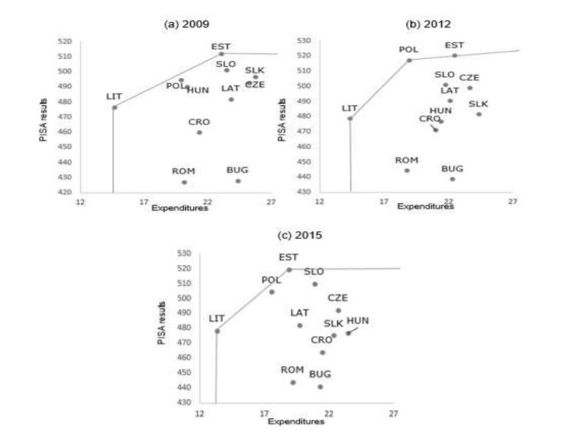

*Figure 2: Quality-Expenditure Charts with Efficiency Frontier (Ahec Sonje et al., 2018)*

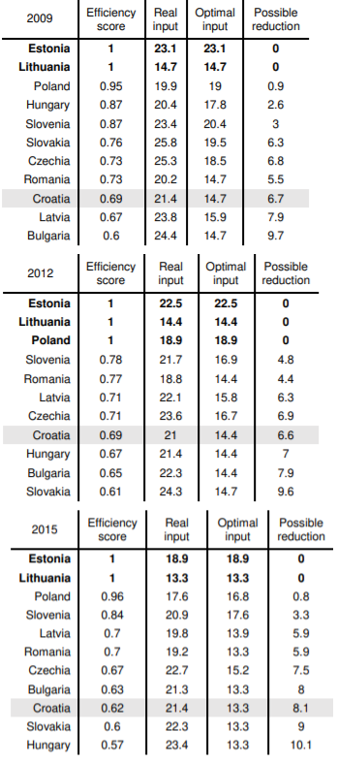

*Table 1: Efficiency Scores (Ahec Sonje et al., 2018)*

Using data envelopment analysis, this study will derive each of the selected countries’ (Bulgaria, Croatia, Hungary, Poland, Romania, Russia Federation, Turkey) efficiency score, visualize the frontier, similar to the study of Ahec Sonje et al. (2018) shown above in Figure 2 and Table 1, and finally the study will compare the results with educational threshold values calculated by the previous method.

*Data Visualization and Comparison*

Based on the methodology introduced in this section, results will be presented and compared using various data visualizations. Expenditure-growth equation and log-log model for school attainment and educational quality will not be applied directly to our data of selected countries but findings of related papers will be discussed and reviewed by our results. Nevertheless, cross-country growth analysis with and without the threshold effect and data envelopment analysis for efficiency scores of countries will be used on selected countries. The results obtained from the application of the last two models will be demonstrated on graphs, line charts (frontier) and they will be listed on tables to be overally discussed.

**V. Statistical Results**

First, I provide a brief summary of the results from “The Effect of Education Expenditure on Per Capita GDP in Developing Countries” and “Global Data Set on Education Quality”. Results are interpreted concisely in the next section. After that, descriptive statistics of the selected countries are presented and this is followed by the analysis of empirical results, obtained from the Threshold Regression and Data Envelopment Analysis for Efficiency Scores.

*Results of Education Expenditure and Quality*

Appiah (2017) analyzed the marginal effect of investment in education on per capita GDP in the regression model (the first model in the Empirical Strategy section) based on the following question: “Does an increase in education expenditure have a causal impact on per capita GDP in developing countries?”. The question is answered by the model with a panel of 139 countries over the period 1975-2015 which includes education expenditure (edx), gross enrollment (ger), export rates (export) and specifically labor (*lft*) as a proxy for human capital. All the variables in the model are significant at the 1% level and the marginal effect of education expenditure on per capita GDP is calculated by subtracting the value of the quadratic labor force in a linear way. The calculated value is positive and statistically significant which suggests that education’s marginal effect greatly influences GDP per capita in developing countries with the expansion of education expenditure (Appiah, 2017).

World Bank’s global dataset on education quality is gathered and analyzed by Altionek et al. (2018) with two strategies, international comparison of education quality using the cross-sectional dataset and long-term performance trends (1965-2015) using the panel dataset. In the education quality comparison part, the results showed that less than 50 percent of students reach the minimum global threshold of proficiency in developing countries whereas this rate is 86 percent in developed countries. For intermediate benchmarks, these percentages are 25% for developing countries and 66% for developed countries; and for advanced benchmarks, only 2 percent of students reach the threshold relative to 10 percent of developed countries’ students (Altinok et al., 2018). This distributional information can illuminate the discussion about economic performance and by whom it is driven, innovative minority at the top or educated society at large. As the second and final strategy of World Bank’s policy research paper, long-term performance trends are shown with different indicators. Countries are ranked by the variation in their schooling quality from 1980 and 2015; the largest gains are observed for Hong Kong, Iran and Finland, respectively (Altinok et al., 2018). In another figure, Harmonized Learning Outcomes (HLO) coverage and learning trends for each country are mapped out for each country from 1965 to 2015 which makes this dataset the richest panel on globally comparable education quality currently. Overall, various long-term education and performance trends demonstrate a positive significant relationship between economic growth and educational achievement (Altinok et al., 2018). This correlation is consistent with the results of Hanushek and Woessmann (2012), from the previous policy research paper of World Bank.

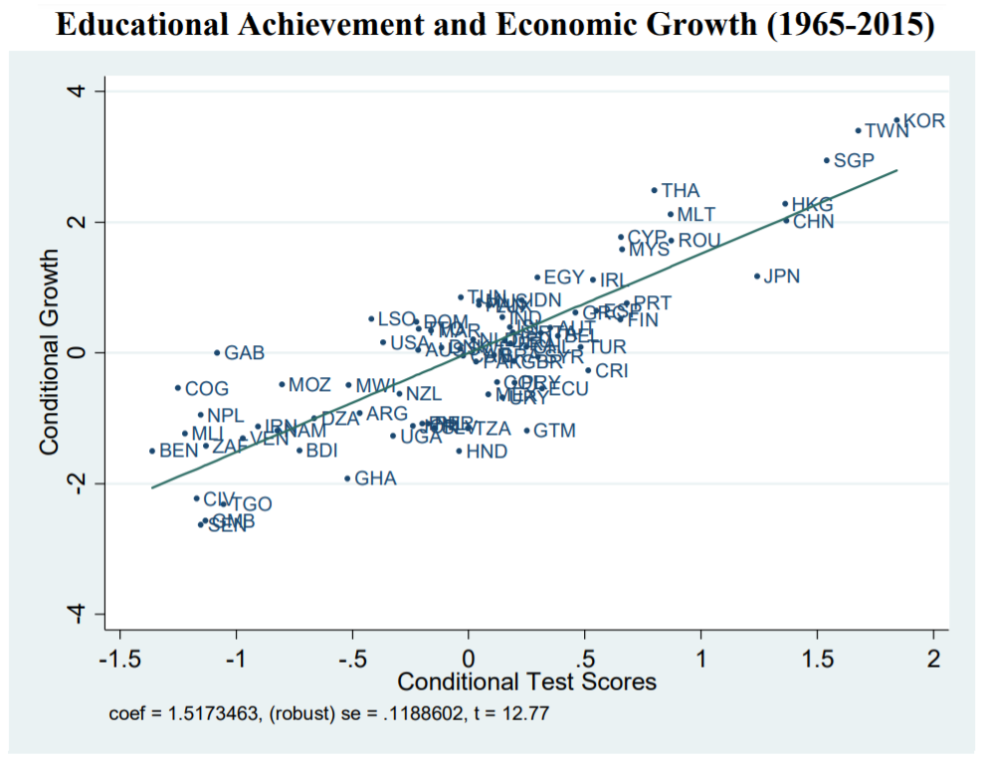

*Figure 3: Education Achievement and Economic Growth 1965-2015 (Altinok et al., 2018)*

Figure 3 shows a regression of;

* 1965-2015 average of annual real GDP per capita growth (in percent) 🡪 y-axis
* average scores on international achievement tests. 🡪 x-axis

*Descriptive Statistics*

The summary statistics are calculated for the selected countries, seven of the 16 emerging and developing economies in Europe according to IMF’s World Economic Outlook Database, for the period 1995-2020. The start year is chosen 1995 because of the data availability of Croatia. Among the selected countries; Bulgaria, Croatia, Hungary, Poland, and Romania are member states of the EU. Although Russian Federation and Turkey are non-member states, they are integrated into Europe in terms of trade agreements and the customs union. The selected countries have the highest GDP per capita in 16 developing countries of Europe.

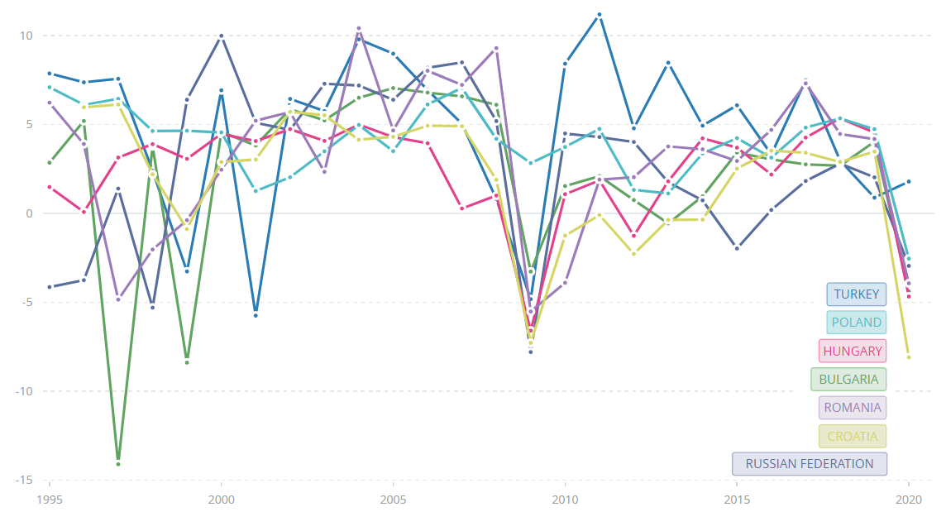GDP Growth (Annual %) 1995-2020

*Figure 4: GDP Growth (Annual %) from World Bank and OECD National Accounts Data*

In Figure 4, GDP growths of the selected countries are shown in annual percentage between 1995-2020. Fluctuations of the growth rates are mostly distinct. Bulgaria shows extreme negative growth in the late 90s and generally, Turkey has higher growth rates during the whole period. However, it can be easily detected that they all are affected negatively by the financial crisis of 2007-2008 or the Great Recession. Additionally, the Covid-19 pandemic caused sudden negative growth for all of the selected countries except Turkey with 1.79 percent growth.

|  |  |  |  |  |  |  |
| --- | --- | --- | --- | --- | --- | --- |
| **Country** | **GROWTH** | **EDU** | **MATH** | **READING** | **SCIENCE** | **QUALITY** |
| **Bulgaria** | 2.12% | 3.59% | 431.2473 | 424.8511 | 439.6622 | 431.9202 |
| **Croatia** | 1.88% | 3.84% | 465.3123 | 480.7061 | 483.7357 | 476.5847 |
| **Hungary** | 2.31% | 4.67% | 484.8683 | 481.7659 | 493.9845 | 486.8729 |
| **Poland** | 3.97% | 4.90% | 498.2983 | 502.7978 | 503.5806 | 501.5589 |
| **Romania** | 3.07% | 3.13% | 431.0501 | 424.5401 | 431.1632 | 428.9178 |
| **Russian Federation** | 2.56% | 3.68% | 479.1306 | 464.4985 | 479.716 | 474.4484 |
| **Turkey** | 4.71% | 3.11% | 435.793 | 453.6274 | 444.8613 | 444.7606 |

*Table 2: Growth-Education Indicators of the Selected Countries (from World Bank)*

In Table 2, growth and education-related characteristics of the selected countries are shown. All of these indicators are calculated as the average of the period 1995-2020 similar to the study of Ahec Sonje et al. (2018) to be used in Data Envelopment Analysis for Efficiency Score. GROWTH shows the average annual growth rate, EDU stands for the average of education expenditures share in GDP between 1995 and 2020. MATH, READING and SCIENCE are the average PISA scores for mathematics, reading and science respectively. QUALITY variable is simply calculated by the mean of MATH, READING and SCIENCE scores of the country, same as Ahec Sonje et al. (2018) did. For the average growth rate, Turkey takes the lead with 4.71% and the lowest average growth rate belongs to Croatia. In terms of the average education expenditure share, Poland has the highest share of education expenditures and Turkey has the lowest. Finally, Poland has achieved the best overall PISA score and Romania has performed the worst.

*Empirical Results*

Two complementary growth-education datasets are created for the empirical models:

1. Cross-Country Dataset: The cross-country dataset contains 7 selected developing countries in Europe with the averages of the characteristics (additional indicators to Table 2 are initial GDP in 1995, Human Capital Index, trade openness, investment percentage of GDP) between 1995-2020. This dataset is used in Data Envelopment Analysis and the calculation of efficiency scores. Data is gathered from World Bank, OECD and IMF. (stored in STATA format)
2. Panel Dataset: The panel dataset covers all of the 16 emerging end developing countries in Europe between 1970-2020 as long as the collection of the data is possible. The reason for expanding the scope of this dataset to all 16 countries is to have a sufficient amount of observations for the threshold regression model. Since they show similar characteristics due to similar economic and educational conditions, the extent of the data has increased with the more realistic measurement of the education quality threshold. The panel dataset is created with the following databases of World Bank’s DataBank: World Development Indicators, Education Statistics – All Indicators and Global Financial Development. (stored in STATA format)

After the data is collected from the World Bank database, it is merged using STATA. First, the growth model with threshold regression is created with some of the control variables from the log-log model used by Son et al. (2013). The threshold regression is applied to the panel dataset introduced above. The impact of the selected variables below and above the threshold of education quality is observed. In the second step, the average values of the selected indicators between the years 1995-2020 are collected from World Bank, OECD and IMF, calculated with STATA for the cross-country dataset. Provided functionality of Data Envelopment Analysis for Efficiency Scores (Ahec Sonje et al., 2018) is developed in Python based on the cross-country dataset. Data points are shown with the efficiency frontier in the scatter plot which is programmed by using Matplotlib library (plotting library for Python programming language) of Python.

**The Threshold Regression Model**

* growth: GDP growth (annual %)
* educexp: education expenditure (% of GNI)
* trade: trade openness (trade share % of GDP)
* lexpect: life expectancy
* inflation: inflation rate
* unemp: unemployment (% of total labor force)
* quality: education quality (average PISA scores from Mathematics, Science and Reading)

|  |  |  |  |  |  |  |
| --- | --- | --- | --- | --- | --- | --- |
| VARIABLES | growth | growth | growth | growth | growth | growth |
|  |  |  |  |  |  |  |
| educexp | -0.598** | -0.589** | -0.855*** | -0.828*** | -0.644*** | -0.585** |
|  | (0.232) | (0.237) | (0.281) | (0.283) | (0.245) | (0.278) |
| linitgdp |  | -0.0645 | 0.0109 | 0.0112 | -0.126 | -0.290 |
|  |  | (0.171) | (0.177) | (0.178) | (0.166) | (0.201) |
| trade |  |  | 0.0165* | 0.0136 | 0.00442 | -0.000829 |
|  |  |  | (0.00967) | (0.0104) | (0.00937) | (0.00979) |
| lexpect |  |  |  | 0.0392 | -0.0268 | 0.0343 |
|  |  |  |  | (0.0657) | (0.0570) | (0.0839) |
| inflation |  |  |  |  | -0.00651*** | -0.00648*** |
|  |  |  |  |  | (0.000822) | (0.000835) |
| unemp |  |  |  |  |  | -0.0640 |
|  |  |  |  |  |  | (0.0439) |
|  |  |  |  |  |  |  |
| Observations | 406 | 403 | 398 | 395 | 367 | 341 |
| R-squared | 0.016 | 0.015 | 0.023 | 0.023 | 0.170 | 0.175 |

Standard errors in parentheses

*** p<0.01, ** p<0.05, * p<0.1

*Table 3: Results of the Regression without Threshold (Robustness Check)*

QUALITY THRESHOLD = 466.69199

|  |  |  |
| --- | --- | --- |
|  |  |  |
| VARIABLES | Region1 | Region2 |
|  |  |  |
| linitgdp | -0.122 | 0.236 |
|  | (0.217) | (0.476) |
| educexp | -0.832*** | 1.550** |
|  | (0.315) | (0.787) |
| trade | -0.0214 | -0.00287 |
|  | (0.0134) | (0.0139) |
| lexpect | -0.314*** | -0.0375 |
|  | (0.111) | (0.249) |
| inflation | -0.00146 | -0.301* |
|  | (0.0502) | (0.179) |
| unemp | -0.0508 | -0.179* |
|  | (0.0371) | (0.107) |
|  |  |  |
| Observations | 203 | 203 |

Standard errors in parentheses

*** p<0.01, ** p<0.05, * p<0.1

Region1: average PISA score 466.70

Region2: average PISA score 466.70

*Table 4: The Threshold Regression Results*

The threshold regression model divides the regression into two regions. Region1 represents the regression when the value is below the threshold level and Region2 is for the region above the threshold level. The estimated quality threshold (average PISA score) is equal to 466.70 which can be seen in Table 4. Compared to the threshold value obtained by Trabelsi (2017) which is 428.29, our estimated threshold is relatively high because this regression model is conducted with 16 developing countries in Europe instead of using 50 developing countries like in Trabelsi’s model and used extra control variables. In Region1, education expenditure and life expectancy are statistically significant at the 1% significance level. In Region2 on the other hand, education expenditure is statistically significant at the 5% significance level where inflation and unemployment are significant at the 10% level. When the education quality is below 466.70 average PISA score, countries can not benefit from the education expenditure and even increasing share of education expenditure harms economic growth. Life expectancy has also negative effect on growth in Region1 which can be related to the aging population and decreasing labor force. For Region2 where education quality is above 466.70 points, one percentage point increase of education expenditure share in GDP increases the growth rate of GDP by 1.55 percentage points. In terms of negative impacts, increasing inflation and unemployment decreases economic growth.

**Efficiency Scores by DEA**

Following the same procedure and non-parametric linear programming techniques, the efficiency score model is programmed to calculate the selected countries’ education expenditure efficiency by measuring their distance to the frontier which is formed by the most efficient countries.

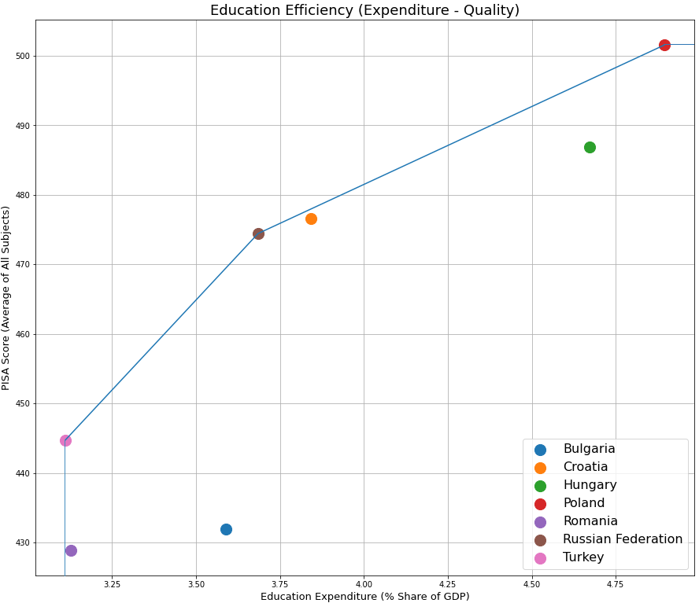

*Figure 5: Education Expenditure – Education Quality Graph with the Efficiency Frontier*

Figure 5 is based on the same structure as the demonstration of Ahec Sonje et al. (2018) in Figure 2. However, education expenditure’s percentage share of GDP is selected as an input variable instead of the direct education expenditure due to huge differences between the selected countries. Also, countries’ government expenditures are correlated with GDP and their population since financed services are used by the citizens of these countries. Thus, using the education expenditure share is a better estimation for the efficiency score model. Turkey, Russian Federation and Poland appear as the most efficient countries or the countries on the efficiency frontier. Since other countries’ efficiency scores (between 0-1) are calculated by their distance from the closest side of the frontier, Romania and Croatia are expected to have very high-efficiency scores.

|  |  |  |
| --- | --- | --- |
| **Country** | **Efficiency Score** | **Efficiency Reference Set** |
| **Bulgaria** | 86.66% | Turkey |
| **Croatia** | 98.40% | Poland, Russian Federation |
| **Hungary** | 90.73% | Poland, Russian Federation |
| **Poland** | 100.00% | - |
| **Romania** | 99.45% | Turkey |
| **Russian Federation** | 100.00% | - |
| **Turkey** | 100.00% | - |

*Table 5: Efficiency Scores of the Selected Countries*

In Table 5, efficiency scores and efficiency reference sets of the selected countries are presented. As explained before; Poland, Russian Federation and Turkey have an efficiency score of 1 (100%) since they are on the convex efficiency frontier. They are the countries that can efficiently benefit from the education expenditure and see the impact on their educational quality. Apart from the efficient countries, the efficiency scores of Romania, Croatia, Hungary and Bulgaria go in the following descending order respectively: 0.9945, 0.9840, 0.9073 and 0.8666. Bulgaria is the least efficient country which was the case in the research of Ahec Sonje et al. (2018) as well. Efficiency reference set shows the closest line of the efficiency frontier from an inefficient country. As can be seen in Figure 5, the vertical blue line between Turkey and the x-axis is the reference set that includes only Turkey which is the closest side of the frontier for Romania and Bulgaria. Lastly, the line between Russian Federation and Poland is the closest side of the frontier for Croatia and Hungary.

|  |  |  |  |
| --- | --- | --- | --- |
| **Country** | **Efficiency Score** | **Education Quality (PISA Score)** | **Above Threshold?** |
| **Bulgaria** | 86.66% | 431.9202 | No |
| **Croatia** | 98.40% | 476.5847 | Yes |
| **Hungary** | 90.73% | 486.8729 | Yes |
| **Poland** | 100.00% | 501.5589 | Yes |
| **Romania** | 99.45% | 428.9178 | No |
| **Russian Federation** | 100.00% | 474.4484 | Yes |
| **Turkey** | 100.00% | 444.7606 | No |

*Table 6: Comparison Table*

|  |  |  |  |  |  |
| --- | --- | --- | --- | --- | --- |
|  |  |  | *Efficiency Score* | |  |
|  |  | **<90%** | **90%-95%** | **95%-100%** | **100%** |
|  | Above | 0 | 1 | 1 | 2 |
| *Threshold* | Below | 1 | 0 | 1 | 1 |
|  | **Total** | **1** | **1** | **2** | **3** |

*Table 7: Cross-Tabulation*

When we look at Table 6, we can see that Poland and Russian Federation are above the education quality threshold from the efficient countries but Turkey is below this threshold. In other words, Poland and Russian Federation can take full advantage of education expenditures to increase their education quality and since they are above the threshold their government expenditure on education can positively affect their economic performance thanks to their high educational quality. For Turkey and Romania, we can say that reaching the education quality threshold is the best strategy to stimulate growth because they are capable of efficiently increasing the quality by education expenditures. Additionally, Croatia can also efficiently increase education quality to test its potential extra effects on economic growth. Moreover, Hungary can try to maintain its educational quality since it is already above the threshold and lastly, Bulgaria is still inefficient (Bulgaria was one of the least efficient countries in the previous study of education expenditure efficiency) and below the education quality threshold which is an important motivation to investigate the reasons behind its comparative inefficiency of education expenditures. This investigation can also be a reasonable subject for further studies about the effect of education expenditure on economic performance.

**VI. Conclusion**

In this study, education quality’s effect on the relationship between economic growth and education expenditure is examined. The major contribution of this policy research paper is to determine the quality threshold and efficiency scores of Europe’s developing countries. Combining the results from these two variables and interpreting them in consideration of previous studies’ findings can create a useful perspective for the link between education and growth.

The results from the elaborative studies of Appiah (2017) and Altinok et al. (2018) led us to three major conclusions. First, expansion of education expenditure promotes economic growth in developing countries. Other two conclusions also explain how expenditure promotes economic growth for these countries. One of them is that there is a positive significant relationship between economic growth and educational quality which indicates that education expenditure can be effective through increased quality level of education. As the last conclusion, educated society at large should be aimed by developing countries to achieve better economic performance rather than well-educated minority at the top.

In the light of these findings, the results of education quality threshold and efficiency scores suggest that educational quality is a limiting factor for the effect of education expenditure on economic growth. The efficient use of education spending is a way of going over this limit. To fulfill the expenditure’s potential, developing countries should reach the threshold of education quality. Countries below the threshold might find that their investment in education did not boost growth. In fact, increasing the share of education expenditures tends to distort economic performance where educational quality is too low. Although developing countries of Europe have higher threshold level for education quality (the threshold level can increase in time due to technological developments of that time period and countries’ development levels), policymakers should focus on improving educational quality to explore education expenditure’s benefits. However, they also need to pay attention to another concept while improving educational quality with public expenditures: expenditure efficiency. Analyzing similar countries’ expenditure efficiencies can help policymakers to find the reasons for possible comparative inefficiencies. After eliminating these reasons, countries can reach threshold quality faster to promote economic growth.

*Figure 6: Education – Quality – Growth Circle*

Eventually, all of the findings of this study are utilized in a final circular economic strategy for developing countries. Increasing the efficiency of education expenditures can lead to higher educational quality with less money spent. After resources are allocated on education efficiently, the education quality threshold should be exceeded to experience the positive effect of education expenditure on economic growth. As a result of economic growth, increased level of output can be used for the expansion of education expenditure again. The same pattern can be followed repetitively to catch the next threshold values of developing world and achieve sustainable economic growth.

This paper represents the first step of possible broader studies in the future and it contributes to the literature by analyzing two complementary concepts, threshold quality and efficiency score, together to light the way for developing countries. Future studies can expand the scope of the research including other developing countries or some other regions, and compare the results to track the reasons for variations. Apart from education-specific literature, the technical efficiency of public expenditures and the productivity of related systems (such as health services, transportation infrastructure, military technologies, etc.) can be examined together within the same model to infer circular causality.

**VII. Appendix**

1. ***Country Lists***
2. ***Descriptive Statistics***
3. ***Tables from Previous Studies***
4. ***Dataset Variables***
5. ***Used Codes and Commands***

**1.A List of Europe’s Developing Countries**

Albania, Belarus, Bosnia and Herzegovina, Bulgaria, Croatia, Hungary, Kosovo, Moldova, Montenegro, North Macedonia, Poland, Romania, Russia, Serbia, Turkey, Ukraine

**1.B List of the Selected Countries**

Bulgaria, Croatia, Hungary, Poland, Romania, Russian Federation, Turkey

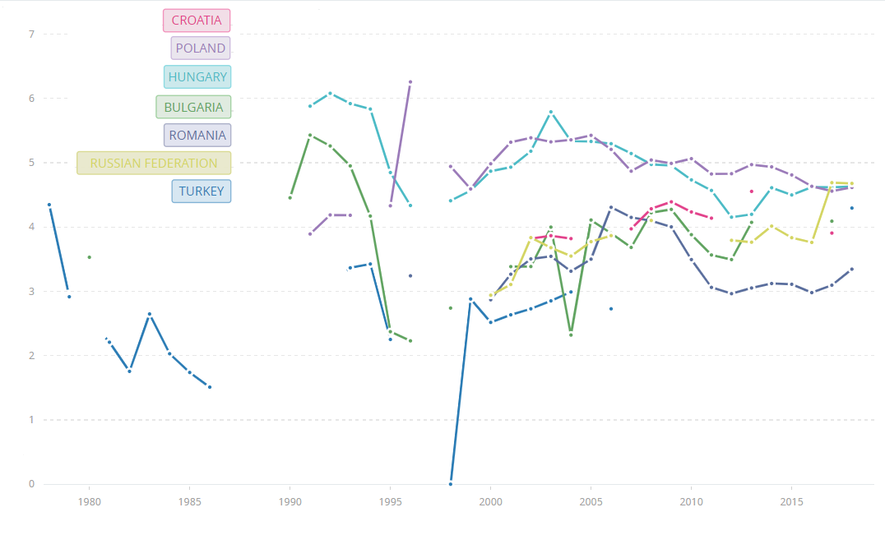**2.A Education Expenditure’s Share on GDP (World Bank)**

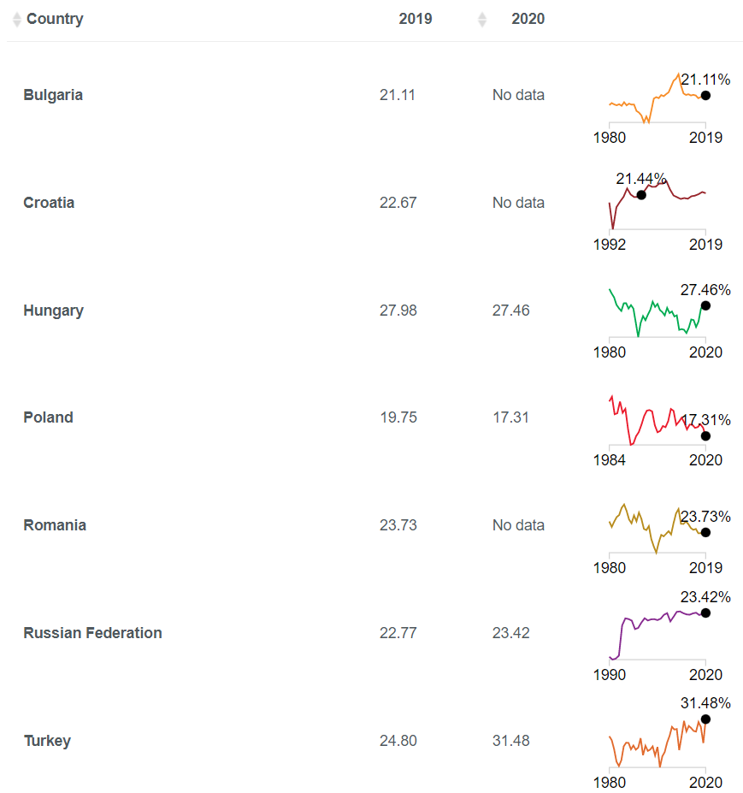**2.B Total Investment - % of GDP (World Bank)**

**2.C Education Expenditure – Growth (Average of 1995-2020)**

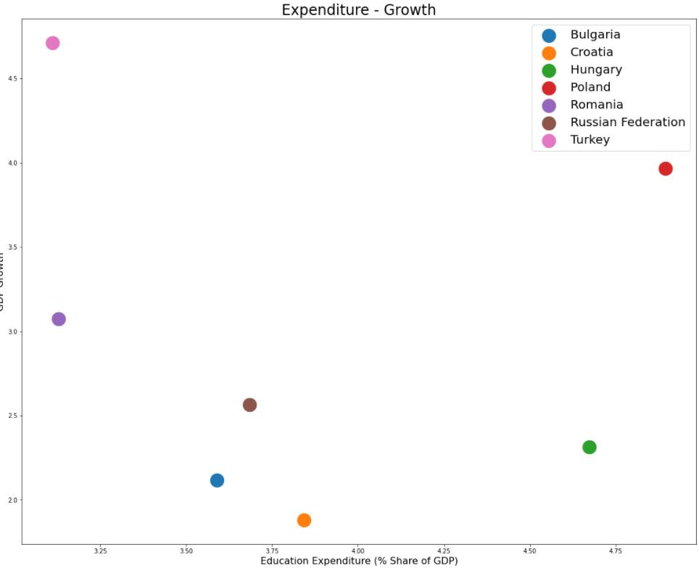

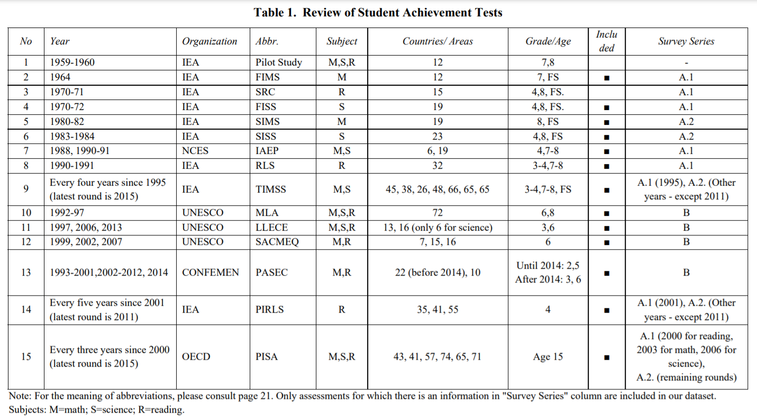**3.A Achievement Tests (Altinok et al., 2018)**

**3.B Population – Benchmarks (Altinok et al., 2018)**

|  |  |  |  |
| --- | --- | --- | --- |
| **Country** | **Minimum Threshold** | **Intermediate Benchmarks** | **Advanced Benchmarks** |
| **Developing Countries** | less than 50% | 25% | 2% |
| **Developed Countries** | 86% | 66% | 10% |

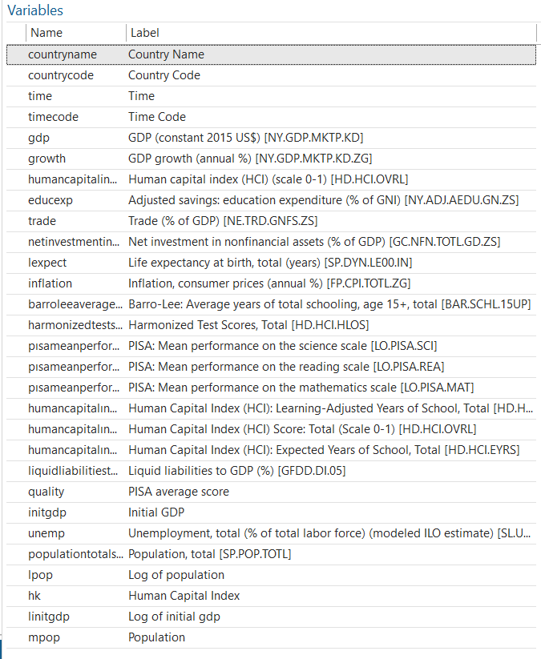**4.A Panel Dataset Variables**

**4.B Cross-Country Dataset Variables**

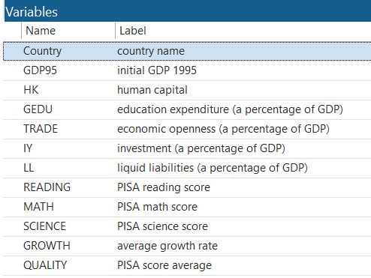

**5.A Stata Commands (do-file)**

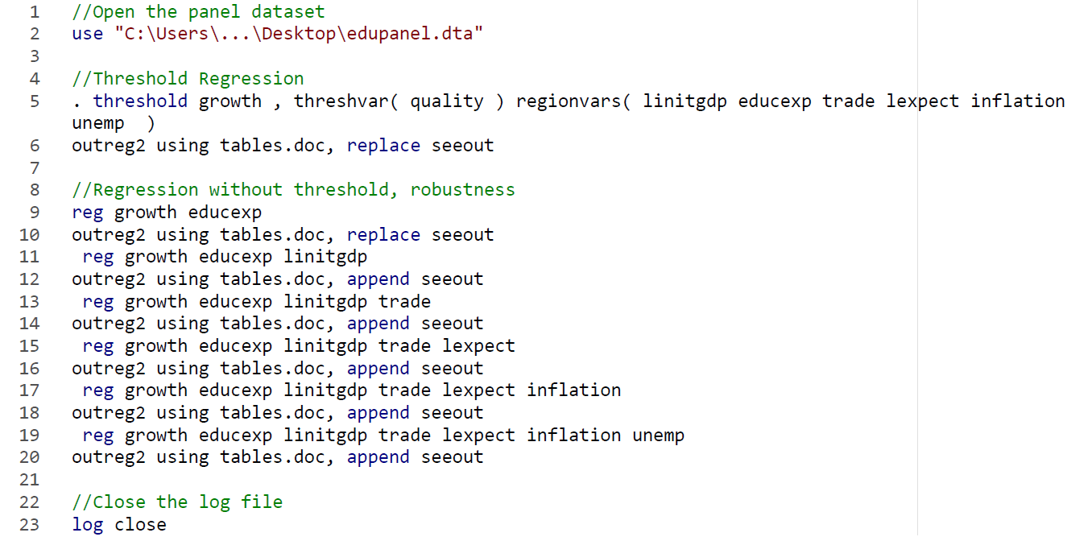

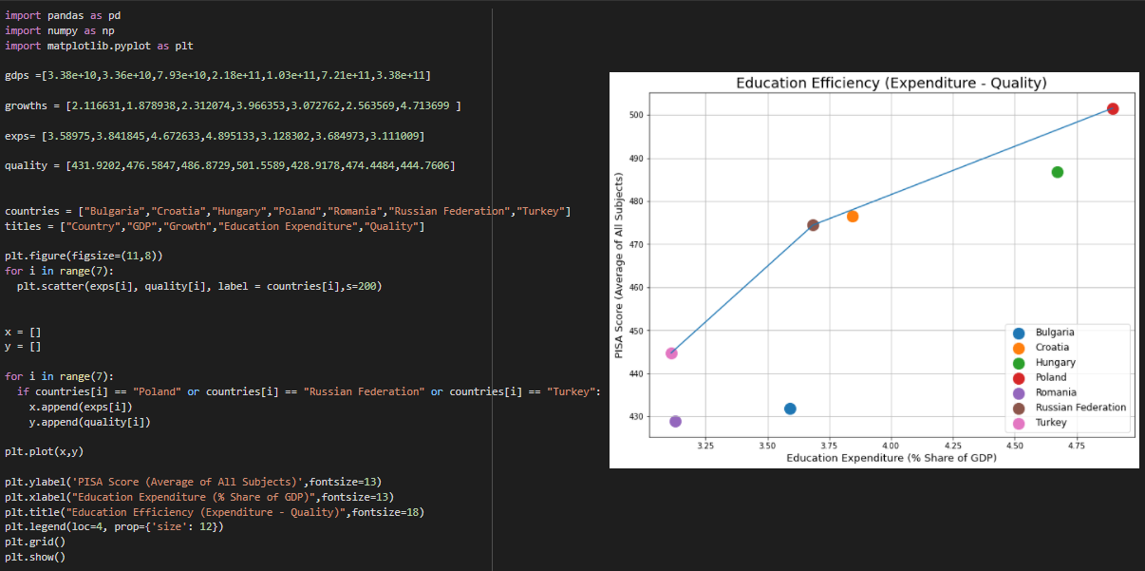**5.B Python Codes**

**VIII. References**

Ahec Sonje, A., Deskar-Skrbic, M., & Sonje, V. (2018). Efficiency of public expenditure on education: Comparing Croatia with other NMS. *INTED Proceedings*.

Altinok, N., Angrist, N., & Patrinos, H. A. (2018). Global Data Set on Education Quality (1965–2015). *Policy Research Working Paper*, *World Bank*.

Appiah, E. N. (2017). The effect of education expenditure on per capita GDP in developing countries. *International Journal of Economics and Finance*, *9*(10), 136.

Barro, R. J. (2001). Human Capital and Growth. *American Economic Review*, *91*(2), 12–17.

Benos, N., & Zotou, S. (2014). Education and economic growth: A meta-regression analysis. *World Development*, *64*, 669–689.

Blankenau, W. F., Simpson, N. B., & Tomljanovich, M. (2007). Public education expenditures, taxation, and growth: Linking data to theory. *American Economic Review*, *97*(2), 393–397.

Bose, N., Haque, M. E., & Osborn, D. R. (2003). Public Expenditure and Growth in Developing Countries: Education is the Key. *Discussion Paper Series*, *Centre for Growth and Business Cycle Research*.

Brewer, D. J., & McEwan, P. J. (2010). *Economics of education*. Elsevier.

Charnes, A., Cooper, W. W., & Rhodes, E. (1979). Measuring the efficiency of decision-making units. *European Journal of Operational Research*, *3*(4), 339.

Hansen, B. E. (1999). Threshold effects in non-dynamic panels: Estimation, testing, and inference. *Journal of Econometrics*, *93*(2), 345–368.

Hanushek, E. A. (2013). Economic growth in developing countries: The role of Human Capital. *Economics of Education Review*, *37*, 204–212.

Hanushek, E. A., & Woessmann, L. (2007). The role of Education Quality for Economic Growth. *Policy Research Working Papers*, *World Bank*.

Mankiw, N. G. (2007). *Principles of microeconomics*. Thomson South-Western.

Mankiw, N. G., Romer, D., & Weil, D. (1992). A contribution to the empirics of economic growth.

Mehrara, M., & Musai, M. (2013). The relationship between economic growth and human capital in developing countries. *International Letters of Social and Humanistic Sciences*, *5*, 55–62.

Mercan, M., & Sezer, S. (2014). The effect of education expenditure on economic growth: The case of Turkey. *Procedia - Social and Behavioral Sciences*, *109*, 925–930.

Schaffner, J. A. (2014). *Development economics: Theory, empirical research, and policy analysis*. John Wiley & Sons.

Son, L., Noja, G. G., Ritivoiu, M., & Tolteanu, R. (2013). Education and Economic Growth: an Empirical Analysis of Interdependencies and Impacts Based on Panel Data. *Timisoara Journal of Economics and Business*, *6(19)*, 39–54.

Trabelsi, S. (2017). Public education expenditure and economic growth: the educational quality threshold effect. *Région Et Développement*, *45*, 99–112.

Vorontsova, A., Vasylieva, T., Bilan, Y., Ostasz, G., & Mayboroda, T. (2020). The influence of state regulation of education for achieving the Sustainable Development Goals: Case Study of Central and Eastern European countries. *Administratie Si Management Public*, *34*, 6–26.